**DATA ANALYTICS Q&A**

**1. Mention the differences between Data Mining and Data Profiling?**

|  |  |
| --- | --- |
| Data Mining | Data Profiting |
| Data mining is the process of discovering relevant information that has not yet been identified before. | Data profiling is done to evaluate a dataset for its uniqueness, logic, and consistency. |
| In data mining, raw data is converted into valuable information. | It cannot identify inaccurate or incorrect data values. |

**2. Define the term 'Data Wrangling in Data Analytics.**

[Data Wrangling](https://www.simplilearn.com/data-wrangling-article) is the process wherein raw data is cleaned, structured, and enriched into a desired usable format for better decision making. It involves discovering, structuring, cleaning, enriching, validating, and analyzing data. This process can turn and map out large amounts of data extracted from various sources into a more useful format. Techniques such as merging, grouping, concatenating, joining, and sorting are used to analyze the data. Thereafter it gets ready to be used with another dataset.

**3. What are the various steps involved in any analytics project?**

This is one of the most basic data analyst interview questions. The various steps involved in any common analytics projects are as follows:

Understanding the Problem

Understand the business problem, define the organizational goals, and plan for a lucrative solution.

Collecting Data

Gather the right data from various sources and other information based on your priorities.

Cleaning Data

Clean the data to remove unwanted, redundant, and missing values, and make it ready for analysis.

Exploring and Analyzing Data

Use data visualization and [business intelligence tools](https://www.simplilearn.com/tutorials/data-analytics-tutorial/business-intelligence-tools), data mining techniques, and predictive modeling to analyze data.

Interpreting the Results

Interpret the results to find out hidden patterns, future trends, and gain insights.

4**. What are the common problems that data analysts encounter during analysis?**

The common problems steps involved in any analytics project are:

* Handling duplicate
* Collecting the meaningful right data and the right time
* Handling data purging and storage problems
* Making data secure and dealing with compliance issues

**5. Which are the technical tools that you have used for analysis and presentation purposes?**

[As a data analyst](https://www.simplilearn.com/data-analyst-job-description-article), you are expected to know the tools mentioned below for analysis and presentation purposes. Some of the [popular tools](https://www.simplilearn.com/top-data-analysis-tools-article) you should know are:

MS SQL Server, MySQL

For working with data stored in relational databases

MS Excel, Tableau

For creating reports and dashboards

Python, R, SPSS

For statistical analysis, data modeling, and [exploratory analysis](https://www.simplilearn.com/tutorials/data-analytics-tutorial/exploratory-data-analysis)

MS PowerPoint

For presentation, displaying the final results and important conclusions

**6. What are the best methods for data cleaning?**

* Create a [data cleaning](https://www.simplilearn.com/data-cleaning-why-and-how-to-get-started-article) plan by understanding where the common errors take place and keep all the communications open.
* Before working with the data, identify and remove the duplicates. This will lead to an easy and effective [data analysis process](https://www.simplilearn.com/data-analysis-methods-process-types-article).
* Focus on the accuracy of the data. Set cross-field validation, maintain the value types of data, and provide mandatory constraints.
* Normalize the data at the entry point so that it is less chaotic. You will be able to ensure that all information is standardized, leading to fewer errors on entry.

**7. What is the significance of Exploratory Data Analysis (EDA)?**

* Exploratory data analysis (EDA) helps to understand the data better.
* It helps you obtain confidence in your data to a point where you’re ready to engage a machine learning algorithm.
* It allows you to refine your selection of feature variables that will be used later for model building.
* You can discover hidden trends and insights from the data.

8**. Explain descriptive, predictive, and prescriptive analytics.**

|  |  |  |
| --- | --- | --- |
| Descriptive | Predictive | Prescriptive |
| It provides insights into the past to answer “what has happened” | Understands the future to answer “what could happen” | Suggest various courses of action to answer “what should you do” |
| Uses data aggregation and data mining techniques | Uses statistical models and forecasting techniques | Uses simulation algorithms and optimization techniques to advise possible outcomes |
| Example: An ice cream company can analyze how much ice cream was sold, which flavors were sold, and whether more or less ice cream was sold than the day before | Example: An ice cream company can analyze how much ice cream was sold, which flavors were sold, and whether more or less ice cream was sold than the day before | Example: Lower prices to increase the sale of ice creams, produce more/fewer quantities of a specific flavor of ice cream |

**9. What are the different types of sampling techniques used by data analysts?**

Sampling is a statistical method to select a subset of data from an entire dataset (population) to estimate the characteristics of the whole population.

There are majorly five types of sampling methods:

* Simple random sampling
* Systematic sampling
* Cluster sampling
* Stratified sampling
* Judgmental or purposive sampling

**10. Describe univariate, bivariate, and multivariate analysis.**

Univariate analysis is the simplest and easiest form of data analysis where the data being analyzed contains only one variable.

Example - Studying the heights of players in the NBA.

Univariate analysis can be described using Central Tendency, Dispersion, Quartiles, Bar charts, Histograms, Pie charts, and Frequency distribution tables.

The bivariate analysis involves the analysis of two variables to find causes, relationships, and correlations between the variables.

Example – Analyzing the sale of ice creams based on the temperature outside.

The bivariate analysis can be explained using Correlation coefficients, Linear regression, Logistic regression, Scatter plots, and Box plots.

The multivariate analysis involves the analysis of three or more variables to understand the relationship of each variable with the other variables.

Example – Analysing Revenue based on expenditure.

Multivariate analysis can be performed using Multiple regression, Factor analysis, Classification & regression trees, Cluster analysis, Principal component analysis, Dual-axis charts, etc.

**11. What are your strengths and weaknesses as a data analyst?**

The answer to this question may vary from a case to case basis. However, some general strengths of a data analyst may include strong analytical skills, attention to detail, proficiency in data manipulation and visualization, and the ability to derive insights from complex datasets. Weaknesses could include limited domain knowledge, lack of experience with certain data analysis tools or techniques, or challenges in effectively communicating technical findings to non-technical stakeholders.

**12. What are the ethical considerations of data analysis?**

Some of the most the ethical considerations of data analysis includes:

* Privacy: Safeguarding the privacy and confidentiality of individuals' data, ensuring compliance with applicable privacy laws and regulations.
* Informed Consent: Obtaining informed consent from individuals whose data is being analyzed, explaining the purpose and potential implications of the analysis.
* Data Security: Implementing robust security measures to protect data from unauthorized access, breaches, or misuse.
* Data Bias: Being mindful of potential biases in data collection, processing, or interpretation that may lead to unfair or discriminatory outcomes.
* Transparency: Being transparent about the data analysis methodologies, algorithms, and models used, enabling stakeholders to understand and assess the results.
* Data Ownership and Rights: Respecting data ownership rights and intellectual property, using data only within the boundaries of legal permissions or agreements.
* Accountability: Taking responsibility for the consequences of data analysis, ensuring that actions based on the analysis are fair, just, and beneficial to individuals and society.
* Data Quality and Integrity: Ensuring the accuracy, completeness, and reliability of data used in the analysis to avoid misleading or incorrect conclusions.
* Social Impact: Considering the potential social impact of data analysis results, including potential unintended consequences or negative effects on marginalized groups.
* Compliance: Adhering to legal and regulatory requirements related to data analysis, such as data protection laws, industry standards, and ethical guidelines.

**13. What are some common data visualization tools you have used?**

You should name the tools you have used personally, however here’s a list of the commonly used data visualization tools in the industry:

* Tableau
* Microsoft Power BI
* QlikView
* Google Data Studio
* Plotly
* Matplotlib (Python library)
* Excel (with built-in charting capabilities)
* SAP Lumira
* IBM Cognos Analytics

**Data Analyst Interview Questions On Statistics**

**14. How can you handle missing values in a dataset?**

This is one of the most frequently asked data analyst interview questions, and the interviewer expects you to give a detailed answer here, and not just the name of the methods. There are four methods to handle missing values in a dataset.

Listwise Deletion

In the listwise deletion method, an entire record is excluded from analysis if any single value is missing.

Average Imputation

Take the average value of the other participants' responses and fill in the missing value.

Regression Substitution

You can use multiple-regression analyses to estimate a missing value.

Multiple Imputations

It creates plausible values based on the correlations for the missing data and then averages the simulated datasets by incorporating random errors in your predictions.

**15. Explain the term Normal Distribution.**

Normal Distribution refers to a continuous probability distribution that is symmetric about the mean. In a graph, normal distribution will appear as a bell curve.

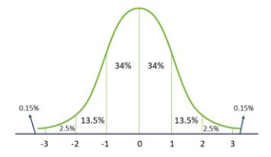

* The mean, median, and mode are equal
* All of them are located in the center of the distribution
* 68% of the data falls within one standard deviation of the mean
* 95% of the data lies between two standard deviations of the mean
* 99.7% of the data lies between three standard deviations of the mean

**16. What is Time Series analysis?**

[Time Series analysis](https://www.youtube.com/watch?v=chp71nEc320) is a statistical procedure that deals with the ordered sequence of values of a variable at equally spaced time intervals. Time series data are collected at adjacent periods. So, there is a correlation between the observations. This feature distinguishes time-series data from cross-sectional data.

Below is an example of time-series data on coronavirus cases and its graph.

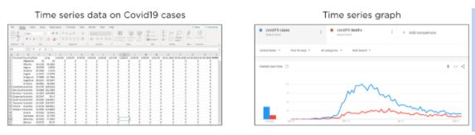

**17. How is Overfitting different from Underfitting?**

This is another frequently asked data analyst interview question, and you are expected to cover all the given differences!

|  |  |
| --- | --- |
| Overfitting | Underfitting |
| The model trains the data well using the training set. | Here, the model neither trains the data well nor can generalize to new data. |
| The performance drops considerably over the test set. | Performs poorly both on the train and the test set. |
| Happens when the model learns the random fluctuations and noise in the training dataset in detail. | This happens when there is lesser data to build an accurate model and when we try to develop a linear model using non-linear data. |

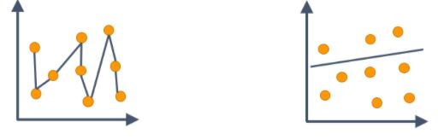

**18. How do you treat outliers in a dataset?**

An outlier is a data point that is distant from other similar points. They may be due to variability in the measurement or may indicate experimental errors.

The graph depicted below shows there are three outliers in the dataset.

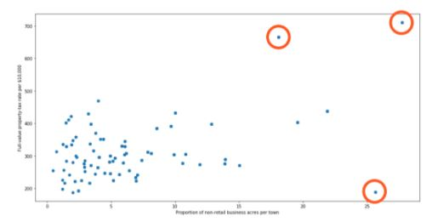

To deal with outliers, you can use the following four methods:

* Drop the outlier records
* Cap your outliers data
* Assign a new value
* Try a new transformation

**19. What are the different types of Hypothesis testing?**

Hypothesis testing is the procedure used by statisticians and scientists to accept or reject statistical hypotheses. There are mainly two types of hypothesis testing:

* Null hypothesis: It states that there is no relation between the predictor and outcome variables in the population. H0 denoted it.

Example: There is no association between a patient’s BMI and diabetes.

* Alternative hypothesis: It states that there is some relation between the predictor and outcome variables in the population. It is denoted by H1.

Example: There could be an association between a patient’s BMI and diabetes.

**20. Explain the Type I and Type II errors in Statistics?**

In Hypothesis testing, a Type I error occurs when the null hypothesis is rejected even if it is true. It is also known as a false positive.

A Type II error occurs when the null hypothesis is not rejected, even if it is false. It is also known as a false negative.

**21. How would you handle missing data in a dataset?**

Ans: The choice of handling technique depends on factors such as the amount and nature of missing data, the underlying analysis, and the assumptions made. It's crucial to exercise caution and carefully consider the implications of the chosen approach to ensure the integrity and reliability of the data analysis. However, a few solutions could be:

* removing the missing observations or variables
* imputation methods including, mean imputation (replacing missing values with the mean of the available data), median imputation (replacing missing values with the median), or regression imputation (predicting missing values based on regression models)
* sensitivity analysis

**22. Explain the concept of outlier detection and how you would identify outliers in a dataset.**

Outlier detection is the process of identifying observations or data points that significantly deviate from the expected or normal behavior of a dataset. Outliers can be valuable sources of information or indications of anomalies, errors, or rare events.

It's important to note that outlier detection is not a definitive process, and the identified outliers should be further investigated to determine their validity and potential impact on the analysis or model. Outliers can be due to various reasons, including data entry errors, measurement errors, or genuinely anomalous observations, and each case requires careful consideration and interpretation.

**Excel Data Analyst Interview Questions**

**23. In Microsoft Excel, a numeric value can be treated as a text value if it precedes with what?**

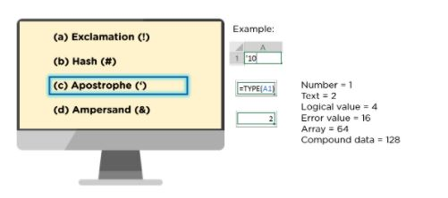

**24. What is the difference between COUNT, COUNTA, COUNTBLANK, and COUNTIF in Excel?**

* COUNT function returns the count of numeric cells in a range
* COUNTA function counts the non-blank cells in a range
* COUNTBLANK function gives the count of blank cells in a range
* COUNTIF function returns the count of values by checking a given condition

**25. How do you make a dropdown list in MS Excel?**

* First, click on the Data tab that is present in the ribbon.
* Under the Data Tools group, select Data Validation.
* Then navigate to Settings > Allow > List.
* Select the source you want to provide as a list array.

**26. Can you provide a dynamic range in “Data Source” for a Pivot table?**

Yes, you can provide a dynamic range in the “Data Source” of Pivot tables. To do that, you need to create a named range using the offset function and base the pivot table using a named range constructed in the first step.

**27. What is the function to find the day of the week for a particular date value?**

The get the day of the week, you can use the WEEKDAY() function.

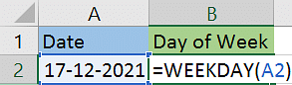

The above function will return 6 as the result, i.e., 17th December is a Saturday.

**28. How does the AND() function work in Excel?**

AND() is a logical function that checks multiple conditions and returns TRUE or FALSE based on whether the conditions are met.

Syntax: AND(logica1,[logical2],[logical3]....)

In the below example, we are checking if the marks are greater than 45. The result will be true if the mark is >45, else it will be false.

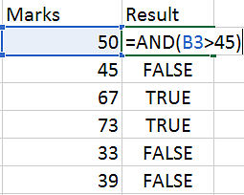

**29. Explain how VLOOKUP works in Excel?**

[VLOOKUP](https://www.simplilearn.com/tutorials/excel-tutorial/vlookup-in-excel) is used when you need to find things in a table or a range by row.

VLOOKUP accepts the following four parameters:

lookup_value - The value to look for in the first column of a table

table - The table from where you can extract value

col_index - The column from which to extract value

range_lookup - [optional] TRUE = approximate match (default). FALSE = exact match

Let’s understand VLOOKUP with an example.

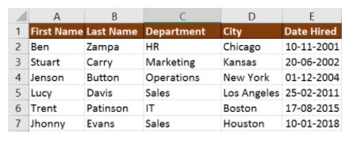

If you wanted to find the department to which Stuart belongs to, you could use the VLOOKUP function as shown below:

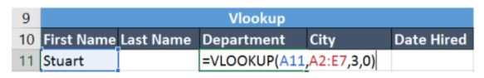

Here, A11 cell has the lookup value, A2:E7 is the table array, 3 is the column index number with information about departments, and 0 is the range lookup.

If you hit enter, it will return “Marketing”, indicating that Stuart is from the marketing department.

**30. What function would you use to get the current date and time in Excel?**

In Excel, you can use the TODAY() and NOW() function to get the current date and time.

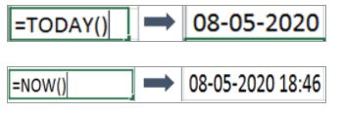

**31. Using the below sales table, calculate the total quantity sold by sales representatives whose name starts with A, and the cost of each item they have sold is greater than 10.**

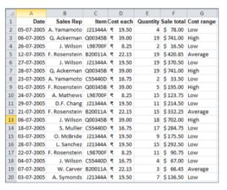

You can use the SUMIFS() function to find the total quantity.

For the Sales Rep column, you need to give the criteria as “A*” - meaning the name should start with the letter “A”. For the Cost each column, the criteria should be “>10” - meaning the cost of each item is greater than 10.

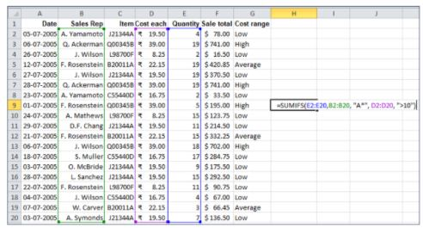

The result is 13.

**33. Using the data given below, create a pivot table to find the total sales made by each sales representative for each item. Display the sales as % of the grand total.**

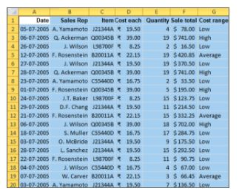

* Select the entire table range, click on the Insert tab and choose PivotTable

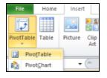

* Select the table range and the worksheet where you want to place the pivot table

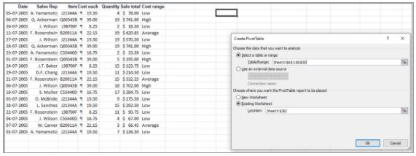

* Drag Sale total on to Values, and Sales Rep and Item on to Row Labels. It will give the sum of sales made by each representative for every item they have sold.

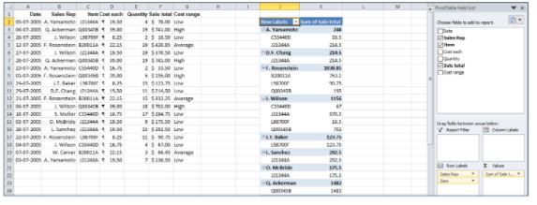

* Right-click on “Sum of Sale Total’ and expand Show Values As to select % of Grand Total.

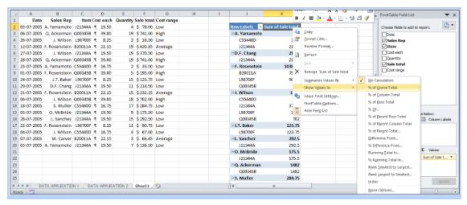

* Below is the resultant pivot table.

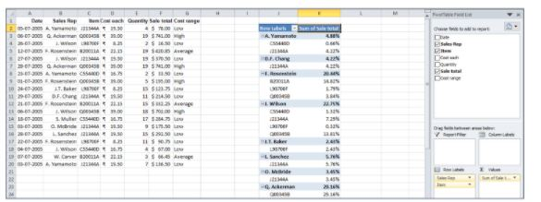

**SQL Interview Questions for Data Analysts**

**34. How do you subset or filter data in SQL?**

To subset or filter data in SQL, we use WHERE and HAVING clauses.

Consider the following movie table.

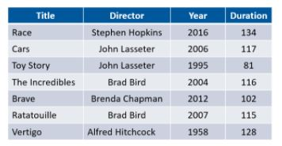

Using this table, let’s find the records for movies that were directed by Brad Bird.

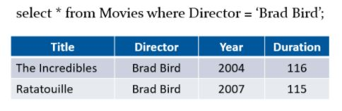

Now, let’s filter the table for directors whose movies have an average duration greater than 115 minutes.

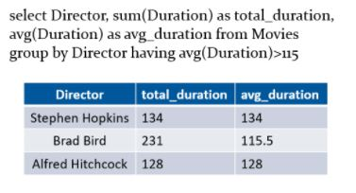

**35. What is the difference between a WHERE clause and a HAVING clause in SQL?**

Answer all of the given differences when this data analyst interview question is asked, and also give out the syntax for each to prove your thorough knowledge to the interviewer.

|  |  |
| --- | --- |
| WHERE | HAVING |
| WHERE clause operates on row data. | The HAVING clause operates on aggregated data. |
| In the WHERE clause, the filter occurs before any groupings are made. | HAVING is used to filter values from a group. |
| Aggregate functions cannot be used. | Aggregate functions can be used. |

Syntax of WHERE clause:

SELECT column1, column2, ...  
FROM table_name  
WHERE condition;

Syntax of HAVING clause;

SELECT column_name(s)  
FROM table_name  
WHERE condition  
GROUP BY column_name(s)  
HAVING condition  
ORDER BY column_name(s);

**36. Is the below SQL query correct? If not, how will you rectify it?**

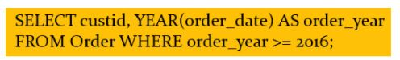

The query stated above is incorrect as we cannot use the alias name while filtering data using the WHERE clause. It will throw an error.

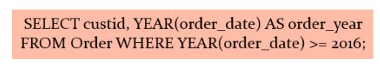

**37. How are Union, Intersect, and Except used in SQL?**

The Union operator combines the output of two or more SELECT statements.

Syntax:

SELECT column_name(s) FROM table1  
UNION  
SELECT column_name(s) FROM table2;

Let’s consider the following example, where there are two tables - Region 1 and Region 2.

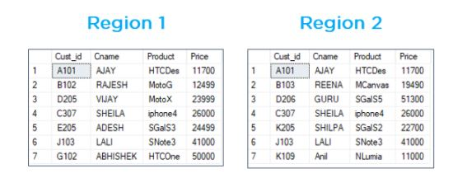

To get the unique records, we use Union.

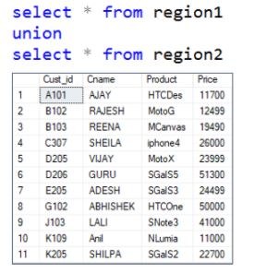

The Intersect operator returns the common records that are the results of 2 or more SELECT statements.

Syntax:

SELECT column_name(s) FROM table1  
INTERSECT  
SELECT column_name(s) FROM table2;

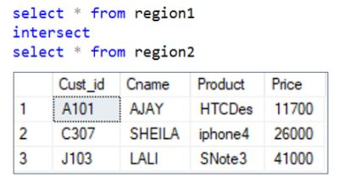

The Except operator returns the uncommon records that are the results of 2 or more SELECT statements.

Syntax:

SELECT column_name(s) FROM table1  
EXCEPT  
SELECT column_name(s) FROM table2;

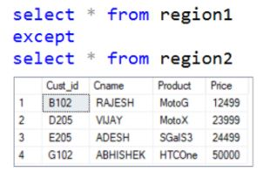

Below is the SQL query to return uncommon records from region 1.

**38. What is a Subquery in SQL?**

A Subquery in SQL is a query within another query. It is also known as a nested query or an inner query. Subqueries are used to enhance the data to be queried by the main query.

It is of two types - Correlated and Non-Correlated Query.

Below is an example of a subquery that returns the name, email id, and phone number of an employee from Texas city.

SELECT name, email, phone

FROM employee

WHERE emp_id IN (

SELECT emp_id

FROM employee

WHERE city = 'Texas');

**39. Using the product_price table, write an SQL query to find the record with the fourth-highest market price.**

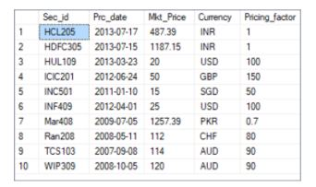

Fig: Product Price table

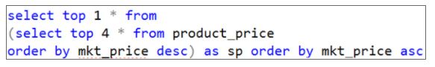

select top 4 * from product_price order by mkt_price desc;

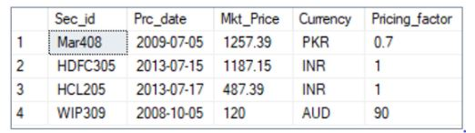

Now, select the top one from the above result that is in ascending order of mkt_price.

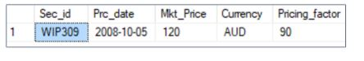

4**0. From the product_price table, write an SQL query to find the total and average market price for each currency where the average market price is greater than 100, and the currency is in INR or AUD.**

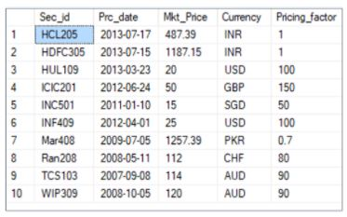

The SQL query is as follows:

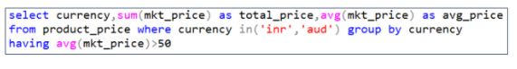

The output of the query is as follows:

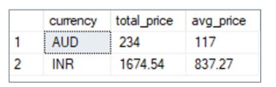

**41. Using the product and sales order detail table, find the products with total units sold greater than 1.5 million.**

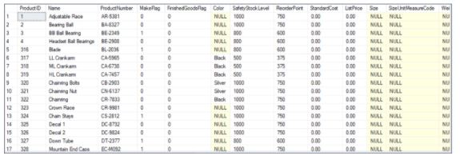

Fig: Products table

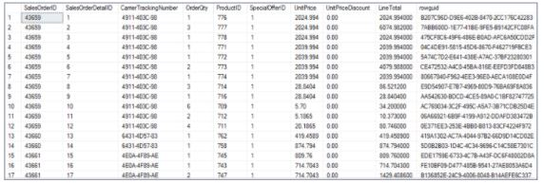

Fig: Sales order detail table

We can use an inner join to get records from both the tables. We’ll join the tables based on a common key column, i.e., ProductID.

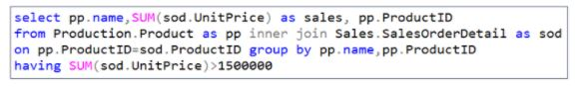

The result of the SQL query is shown below.

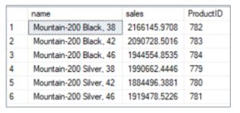

**42. How do you write a**[**stored procedure in SQL**](https://www.simplilearn.com/tutorials/sql-tutorial/stored-procedure-in-sql)**?**

You must be prepared for this question thoroughly before your next data analyst interview. The stored procedure is an SQL script that is used to run a task several times.

Let’s look at an example to create a stored procedure to find the sum of the first N natural numbers' squares.

* Create a procedure by giving a name, here it’s squaresum1
* Declare the variables
* Write the formula using the set statement
* Print the values of the computed variable
* To run the stored procedure, use the EXEC command

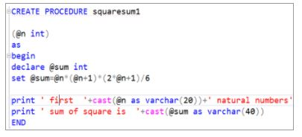

Output: Display the sum of the square for the first four natural numbers

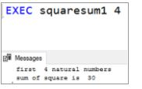

**43. Write an SQL stored procedure to find the total even number between two users given numbers.**

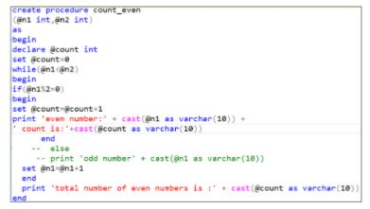

Here is the output to print all even numbers between 30 and 45.

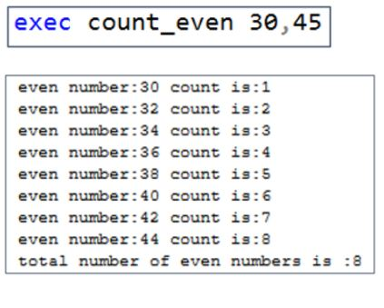

**Tableau Data Analyst Interview Questions**

**44. How is joining different from blending in Tableau?**

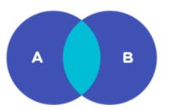

|  |  |
| --- | --- |
| Data Joining | Data Blending |
| Data joining can only be carried out when the data comes from the same source. | Data blending is used when the data is from two or more different sources. |
| E.g: Combining two or more worksheets from the same Excel file or two tables from the same databases.  All the combined sheets or tables contain a common set of dimensions and measures. | E.g: Combining the Oracle table with SQL Server,  or combining Excel sheet and Oracle table or two sheets from Excel.  Meanwhile, in data blending, each data source contains its own set of dimensions and measures. |

**45. What do you understand by LOD in Tableau?**

[LOD in Tableau](https://www.simplilearn.com/tutorials/tableau-tutorial/lod-in-tableau) stands for Level of Detail. It is an expression that is used to execute complex queries involving many dimensions at the data sourcing level. Using LOD expression, you can find duplicate values, synchronize chart axes and create bins on aggregated data.

**46. Can you discuss the process of feature selection and its importance in data analysis?**

Feature selection is the process of selecting a subset of relevant features from a larger set of variables or predictors in a dataset. It aims to improve model performance, reduce overfitting, enhance interpretability, and optimize computational efficiency. Here's an overview of the process and its importance:

Importance of Feature Selection:

- Improved Model Performance: By selecting the most relevant features, the model can focus on the most informative variables, leading to better predictive accuracy and generalization.  
- Overfitting Prevention: Including irrelevant or redundant features can lead to overfitting, where the model learns noise or specific patterns in the training data that do not generalize well to new data. Feature selection mitigates this risk.  
- Interpretability and Insights: A smaller set of selected features makes it easier to interpret and understand the model's results, facilitating insights and actionable conclusions.  
- Computational Efficiency: Working with a reduced set of features can significantly improve computational efficiency, especially when dealing with large datasets.

**47. What are the different connection types in Tableau Software?**

There are mainly 2 types of connections available in Tableau.

Extract: Extract is an image of the data that will be extracted from the data source and placed into the Tableau repository. This image(snapshot) can be refreshed periodically, fully, or incrementally.

Live: The live connection makes a direct connection to the data source. The data will be fetched straight from tables. So, data is always up to date and consistent.

**48. What are the different joins that Tableau provides?**

Joins in Tableau work similarly to the SQL join statement. Below are the types of joins that Tableau supports:

* Left Outer Join
* Right Outer Join
* Full Outer Join
* Inner Join

**49. What is a Gantt Chart in Tableau?**

A Gantt chart in Tableau depicts the progress of value over the period, i.e., it shows the duration of events. It consists of bars along with the time axis. The Gantt chart is mostly used as a project management tool where each bar is a measure of a task in the project.

**50. Using the Sample Superstore dataset, create a view in Tableau to analyze the sales, profit, and quantity sold across different subcategories of items present under each category.**

* Load the Sample - Superstore dataset

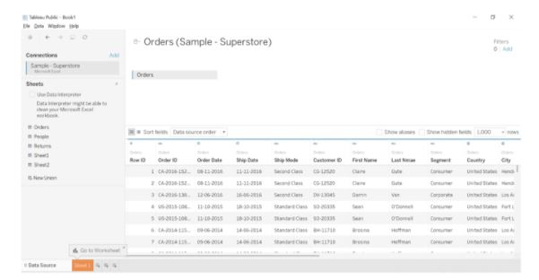

* Drag Category and Subcategory columns into Rows, and Sales on to Columns. It will result in a horizontal bar chart.

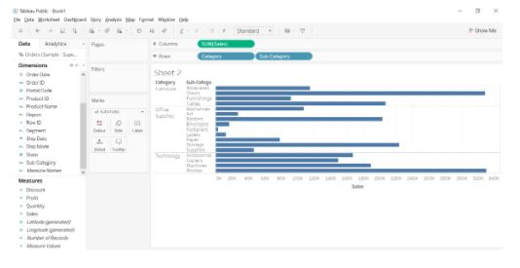

* Drag Profit on to Colour, and Quantity on to Label. Sort the Sales axis in descending order of the sum of sales within each sub-category.

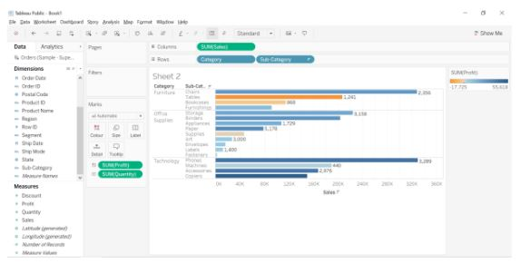

**51. Create a dual-axis chart in Tableau to present Sales and Profit across different years using the Sample Superstore dataset.**

* Drag the Order Date field from Dimensions on to Columns, and convert it into continuous Month.

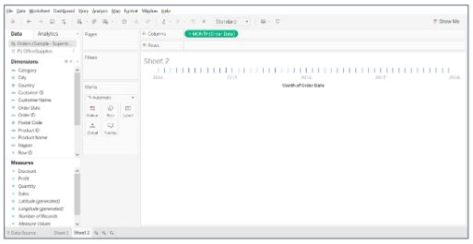

* Drag Sales on to Rows, and Profits to the right corner of the view until you see a light green rectangle.

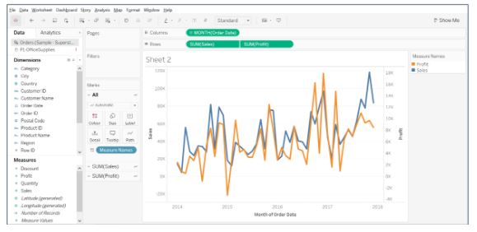

* Synchronize the right axis by right-clicking on the profit axis.

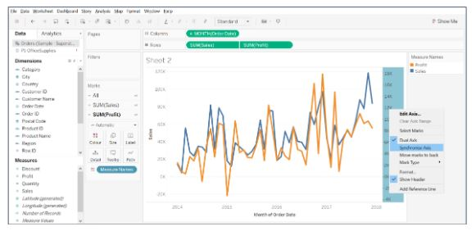

* Under the Marks card, change SUM(Sales) to Bar and SUM(Profit) to Line and adjust the size.

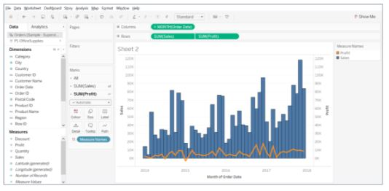

**52. Design a view in Tableau to show State-wise Sales and Profit using the Sample Superstore dataset.**

* Drag the Country field on to the view section and expand it to see the States.

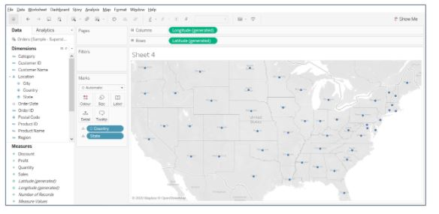

* Drag the Sales field on to Size, and Profit on to Colour.

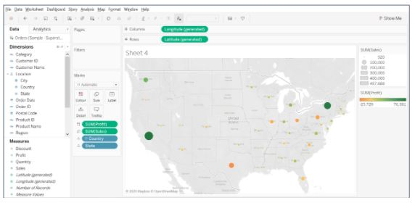

* Increase the size of the bubbles, add a border, and halo color.

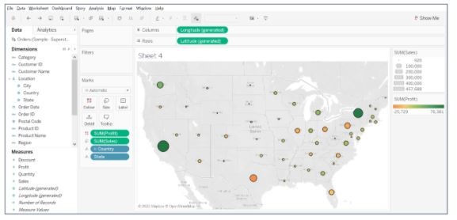

From the above map, it is clear that states like Washington, California, and New York have the highest sales and profits. While Texas, Pennsylvania, and Ohio have good amounts of sales but the least profits.

**53. What is the difference between Treemaps and Heatmaps in Tableau?**

|  |  |
| --- | --- |
| Treemaps  45-treemap | Heatmaps  heatmap |
| Treemaps are used to display data in nested rectangles. | Heat maps can visualize measures against dimensions with the help of colors and size to differentiate one or more dimensions and up to two measures. |
| You use dimensions to define the structure of the treemap, and measures to define the size or color of the individual rectangles. | The layout is like a text table with variations in values encoded as colors. |
| Treemaps are a relatively simple data visualization that can provide insight in a visually attractive format. | In the heatmap, you can quickly see a wide array of information. |

**54. Using the Sample Superstore dataset, display the top 5 and bottom 5 customers based on their profit.**

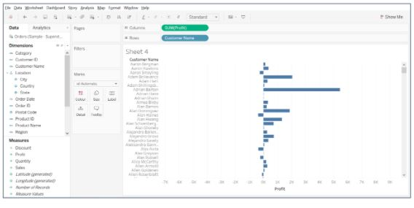

* Drag Customer Name field on to Rows, and Profit on to Columns.

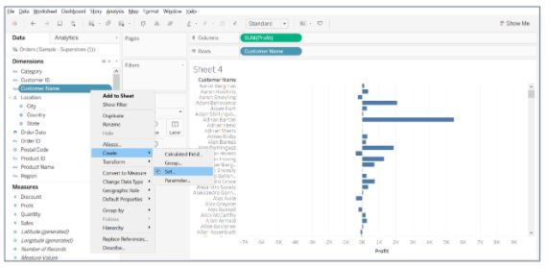

* Right-click on the Customer Name column to create a set

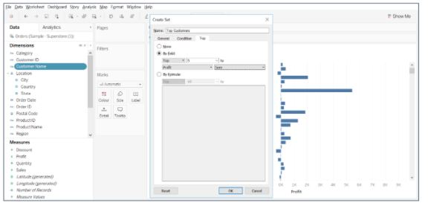

* Give a name to the set and select the top tab to choose the top 5 customers by sum(profit)

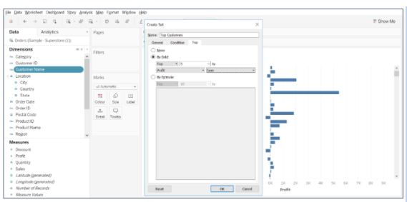

* Similarly, create a set for the bottom five customers by sum(profit)

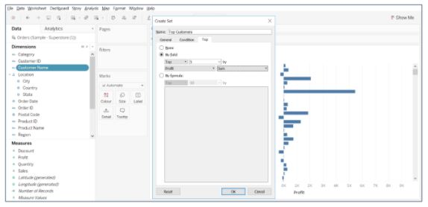

* Select both the sets, right-click to create a combined set. Give a name to the set and choose All members in both sets.

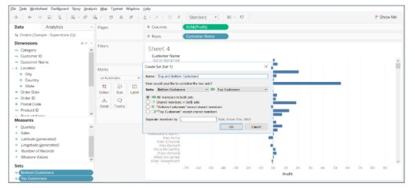

* Drag top and bottom customers set on to Filters, and Profit field on to Colour to get the desired result.

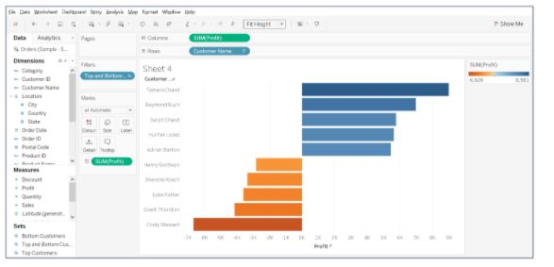

**Data Analyst Interview Questions On Python**

**55. What is the correct syntax for reshape() function in NumPy?**

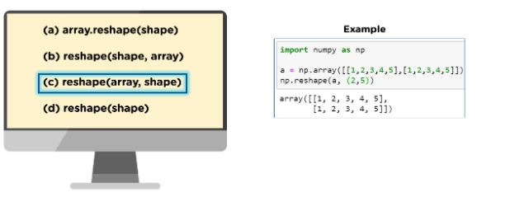

**56. What are the different ways to create a data frame in Pandas?**

There are two ways to create a Pandas data frame.

* By initializing a list

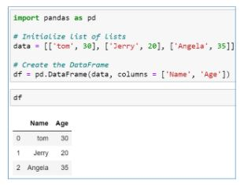

* By initializing a dictionary

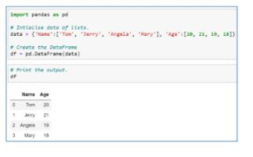

**57. Write the Python code to create an employee’s data frame from the “emp.csv” file and display the head and summary.**

To create a DataFrame in [Python](https://www.simplilearn.com/tutorials/data-analytics-tutorial/data-analytics-with-python), you need to import the Pandas library and use the read_csv function to load the .csv file. Give the right location where the file name and its extension follow the dataset.

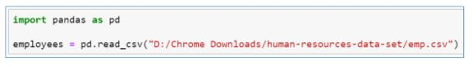

To display the head of the dataset, use the head() function.

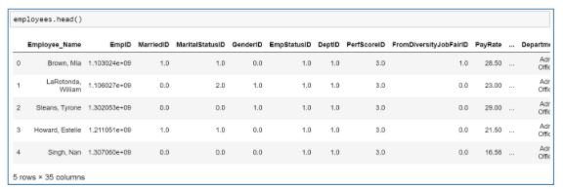

The ‘describe’ method is used to return the summary statistics in Python.

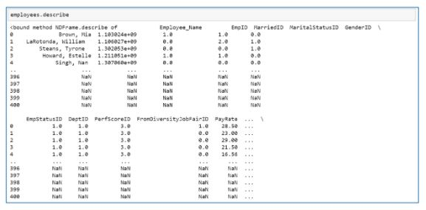

**58. How will you select the Department and Age columns from an Employee data frame?**

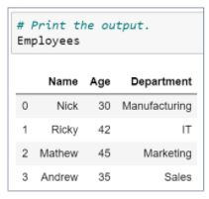

You can use the column names to extract the desired columns.

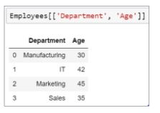

**59. Suppose there is an array, what would you do?**

num = np.array([[1,2,3],[4,5,6],[7,8,9]]). Extract the value 8 using 2D indexing.

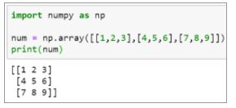

Since the value eight is present in the 2nd row of the 1st column, we use the same index positions and pass it to the array.

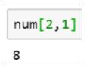

**60. Suppose there is an array that has values [0,1,2,3,4,5,6,7,8,9]. How will you display the following values from the array - [1,3,5,7,9]?**

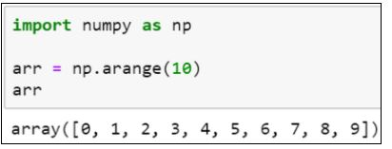

Since we only want the odd number from 0 to 9, you can perform the modulus operation and check if the remainder is equal to 1.

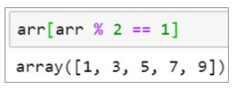

**61. There are two arrays, ‘a’ and ‘b’. Stack the arrays a and b horizontally using the NumPy library in Python.**

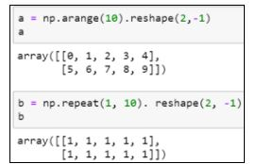

You can either use the concatenate() or the hstack() function to stack the arrays.

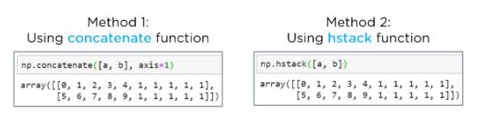

**62. How can you add a column to a Pandas Data Frame?**

Suppose there is an emp data frame that has information about a few employees. Let’s add an Address column to that data frame.

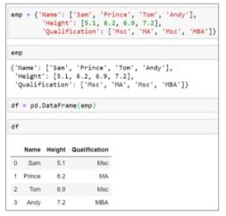

Declare a list of values that will be converted into an address column.

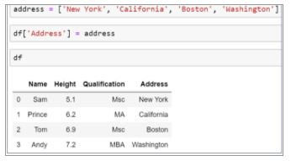

**63. How will you print four random integers between 1 and 15 using NumPy?**

To generate Random numbers using NumPy, we use the random.randint() function.

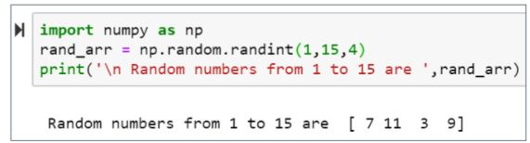

**64. From the below DataFrame, how will you find each column's unique values and subset the data for Age<35 and Height>6?**

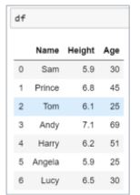

To find the unique values and number of unique elements, use the unique() and nunique() function.

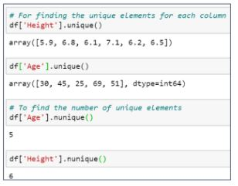

Now, subset the data for Age<35 and Height>6.

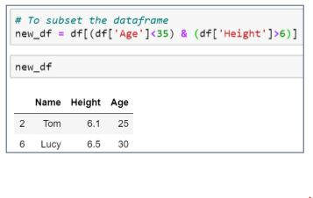

**65. Plot a sine graph using NumPy and Matplotlib library in Python.**

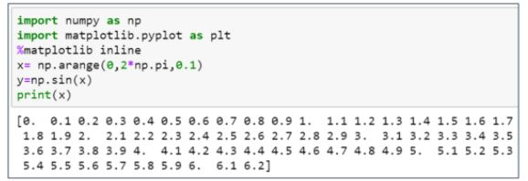

Below is the result sine graph.

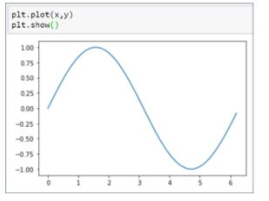

**66. Using the below Pandas data frame, find the company with the highest average sales. Derive the summary statistics for the sales column and transpose the statistics.**

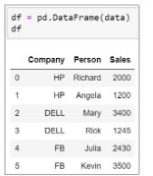

* Group the company column and use the mean function to find the average sales

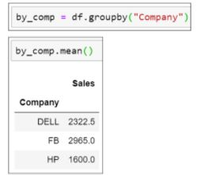

* Use the describe() function to find the summary statistics

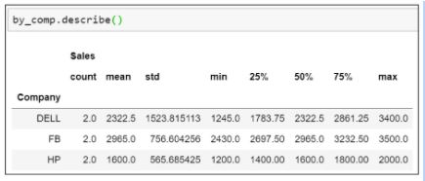

* Apply the transpose() function over the describe() method to transpose the statistics

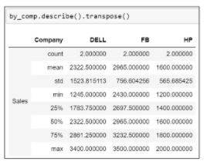

**2. What do data analysts do?**

**What they’re really asking:** Do you understand the role and the value data analysts bring to the company?

If you’re applying for a job as a data analyst, you likely know the basics of what data analysts do. Go beyond a simple definition to demonstrate your understanding of the role and its importance.

Outline the main tasks of a data analyst: identify, collect, clean, analyse, and interpret. Talk about how these tasks can lead to better business decisions, and be ready to explain the value of data-driven decision-making.

An interviewer might also ask:

* What is the process of data analysis?
* What steps do you take to solve a business problem?
* What is your process when you start a new project?

**3. What was your most successful/most challenging data analysis project?**

**What they’re really asking:** What are your strengths and weaknesses?

When an interviewer asks you this type of question, they’re often looking to evaluate your strengths and weaknesses as a data analyst. How do you overcome challenges and measure the success of a data project?

Being asked about a project you’re proud of is a chance to highlight your skills and strengths. Do this by discussing your role in the project and what made it so successful. As you prepare your answer, look at the original job description to see if you can incorporate some of the skills and requirements listed.

If you get asked the negative version of a question (least successful or most challenging project), be honest as you focus your answer on lessons learned. Identify what went wrong—maybe your data was incomplete, or the sample size was too small—and talk about what you’d do differently in the future to correct the error. We’re human, and mistakes are a part of life. What’s important here is your ability to learn from them.

An interviewer might also ask:

* Walk me through your portfolio.
* What is your greatest strength as a data analyst? How about your greatest weakness?
* Tell me about a data problem that challenged you.

**4. What’s the largest data set you’ve worked with?**

**What they’re really asking:** Can you handle large data sets?

Many businesses have more data at their disposal than ever before. Hiring managers want to know you can work with large, complex data sets. Focus your answer on the size and type of data. How many entries and variables did you work with? What types of data were in the set?

The experience you highlight doesn't have to come from a job. You’ll often have the chance to work with data sets of varying sizes and types as a part of a data analysis course, bootcamp, certificate programme, or degree.

As you put together a portfolio, you may also complete some independent projects where you find and analyse a data set. All of this is good material to draw from when you answer.

An interviewer might also ask:

* What type of data have you worked with in the past?
* What problems did you encounter when analysing a data set?

**Data analysis process questions**

The work of a data analyst involves a range of tasks and skills. Interviewers will likely ask questions about various parts of the data analysis process to evaluate how well you perform each step.

**5. Explain how you would estimate . . . ?**

**What they’re really asking:** What’s your thought process? Are you an analytical thinker?

With this question, the interviewer presents you with a problem to solve. How would you estimate the best month to offer a discount on shoes? How would you estimate the weekly profit of your favourite restaurant?

The purpose here is to evaluate your problem-solving ability and overall comfort working with numbers. Since this is about how you think, think out loud as you work through your answer.

* What types of data would you need?
* Where might you find that data?
* Once you have the data, how would you use it to calculate an estimate?

**6. What is your process for cleaning data?**

**What they’re really asking:** How do you handle missing data, outliers, duplicate data, etc.?

As a data analyst, data preparation, also known as data cleaning or data cleansing, will often account for most of your time. A potential employer will want to see that you know the process and why it’s crucial.

In your answer, briefly describe data cleaning and why it’s essential to the overall process. Then walk through the steps you typically take to clean a data set. Consider mentioning how you handle:

* Missing data
* Duplicate data
* Data from different sources
* Structural errors
* Outliers

An interviewer might also ask:

* How do you deal with messy data?
* What is data cleaning?

**7. How do you explain technical concepts to a non-technical audience?**

**What they’re really asking:** How are your communication skills?

While drawing insights from data is a critical skill for a data analyst, communicating those insights to stakeholders, management, and non-technical co-workers is just as important.

Your answer should include the types of audiences you’ve presented to in the past (size, background, context). If you don’t have a lot of experience presenting, you can still talk about how you’d present data findings differently depending on the audience.

An interviewer might also ask:

* What is your experience conducting presentations?
* Why are communication skills important to a data analyst?
* How do you present your findings to management?

**Tip:** In some cases, your interviewer might not be involved in data analysis. The entire interview, then, is an opportunity to demonstrate your ability to communicate clearly. Consider practicing your answers on a non-technical friend or family member.

**8. Tell me about a time when you got unexpected results.**

**What they’re really asking:** Do you let the data or your expectations drive your analysis?

Effective data analysts let the data tell the story. After all, data-driven decisions are based on facts rather than intuition or gut feelings. When asking this question, an interviewer might be trying to determine:

* How you validate results to ensure accuracy
* How you overcome selection bias
* If you’re able to find new business opportunities in surprising results

Describe the situation that surprised you and what you learned from it. This is your opportunity to demonstrate your natural curiosity and excitement to learn new things from data.

**9. How would you measure the performance of our company?**

**What they’re really asking:** Have you done your research?

Before your interview, research the company, its business goals, and the larger industry. Consider the business problems that data analysis can solve and what types of data you’d need to analyze. Read up on how data is used by competitors and in the industry.

Show that you can be business-minded by tying this back to the company. How would this analysis bring value to their business?

**Technical skill questions**

Interviewers will seek candidates who can leverage various technical data analyst skills. These questions are geared towards evaluating your competency across several skills.

**10. What data analytics software are you familiar with?**

**What they’re really asking**: Do you have basic competency with common tools? How much training will you need?

This is an excellent time to revisit the job listing to look for any software emphasised in the description. As you answer, explain how you’ve used that software (or something similar). Show your familiarity with the tool by using associated terminology.

Mention software solutions you’ve used for various stages of the data analysis process. You don’t need to go into great detail here. What you used and what you used it for should suffice.

An interviewer might also ask:

* What data software have you used in the past?
* What data analytics software are you trained in?

**Tip:** In some cases, your interviewer might not be involved in data analysis. The entire interview, then, is an opportunity to demonstrate your ability to communicate clearly. Consider practicing your answers on a non-technical friend or family member.

**11. What scripting languages do you know?**

As a data analyst, you’ll likely have to use SQL and a statistical programming language like R or Python. If you’re already familiar with the language of choice at the company you’re applying to, great. If not, you can take this time to show enthusiasm for learning. Point out that your experience with one (or more) languages has set you up for success in learning new ones. Talk about how you’re currently growing your skills.

An interviewer might also ask:

* What functions in SQL do you like most?
* Do you prefer R or Python?

**Five SQL interview questions for data analysts**

Knowledge of SQL is one of the most important skills you can have as a data analyst. Many interviews for data analyst jobs include an SQL screening where you’ll be asked to write code on a computer or whiteboard. Here are five SQL questions and tasks to prepare for:

**1. Create an SQL query:** Be ready to use JOIN and COUNT functions to show a query result from a given database.

**2. Describe an SQL query:** Given an SQL query, explain what data is being retrieved.

**3. Modify a database:** Insert new rows, modify existing records, or permanently delete records from a database.

**4. Debug a query:** Correct the errors in an existing query to make it functional.

**5. Define an SQL term:** Understand what terms like foreign and primary key, truncate, drop, union, union all, and left join and inner join mean (and when you’d use them).

**12. What statistical methods have you used in data analysis?**

**What they’re really asking**: Do you have basic statistical knowledge?

Most entry-level data analyst roles will require at least a basic competency in statistics and an understanding of how statistical analysis ties into business goals. List the statistical calculations you’ve used and what business insights those calculations yielded.

If you’ve ever worked with or created statistical models, mention that. If you’re not already, familiarise yourself with the following statistical concepts:

* Mean
* Standard deviation
* Variance
* Regression
* Sample size
* Descriptive and inferential statistics

An interviewer might also ask:

* What is your knowledge of statistics?
* How have you used statistics in your work as a data analyst?

**13. How have you used Excel for data analysis in the past?**

Spreadsheets rank among the most common tools used by data analysts. It’s common for interviews to include one or more questions meant to gauge your skill in working with data in Microsoft Excel.

**Five Excel interview questions for data analysts**

Here are five more questions specific to Excel that you might be asked during your interview:

1. What is a VLOOKUP, and what are its limitations?

2. What is a pivot table, and how do you make one?

3. How do you find and remove duplicate data?

4. What are INDEX and MATCH functions, and how do they work together?

5. What’s the difference between a function and a formula?

**14. Explain the term…**

**What they’re asking:** Are you familiar with the data analytics terminology?

You may be asked to define a term or explain its meaning throughout your interview. In most cases, the interviewer is trying to determine how well you know the field and how effectively you communicate technical concepts in simple terms. While it’s impossible to know what exact terms you may be asked about, here are a few you should be familiar with:

* Normal distribution
* Data wrangling
* KNN imputation method
* Clustering
* Outlier
* N-grams
* Statistical model

**15. Can you describe the difference between . . . ?**

Similar to the last type of question, these interview questions help determine your knowledge of analytics concepts by asking you to compare two related terms. Some pairs you might want to be familiar with include:

* Data mining versus data profiling
* Quantitative versus qualitative data
* Variance versus covariance
* Univariate versus bivariate vs. multivariate analysis
* Clustered versus non-clustered index
* 1-sample T-test versus 2-sample T-test in SQL
* Joining versus blending in Tableau